**Supplementary information for:**

**AI guided robotic synthesis of aspirin: an undergraduate practical**

Matthew Nel,a Kariska Potgieter,b Oyekunle Alimi,b Andre L. Nela and Reinout Meijboom*,b

*aDepartment of Mechanical Engineering, University of Johannesburg, PO Box 524, Auckland Park 2006, Johannesburg, South Africa.*

*bDepartment of Chemical Sciences, University of Johannesburg, PO Box 524, Auckland Park 2006, Johannesburg, South Africa. Tel.: +27 (0)11 559 2367; Fax.: +27 (0)11 559 2819. E-mail:* [*rmeijboom@uj.ac.za*](mailto:rmeijboom@uj.ac.za)

Contents

1. Installing software and drivers 3

2. Generating reactions 6

3. Performing reactions 7

# Installing software and drivers

**Python**

To run the aspirin synthesis the user must first install Python. Pycont has been tested for compatibility with Python 3.8. It is recommended that the user install the Anaconda distribution as this includes packages required to run the LabMate.ML package.

Python can be installed from: <https://www.python.org/downloads/>

Anaconda is available to individual users as a free download at: <https://www.anaconda.com/products/individual>.

**Pycont**

Pycont is an open-source package for controlling Tricontinent syringe pumps developed by the Cronin Group at the University of Glasgow [1]. A fork of this package including serial USB drivers, STL files for the tiles, and the scripts for the aspirin synthesis is available at the following link:

<https://github.com/UJMetaCatalysis/aspirin_optimisation_practical>

The repository can be downloaded as a zipped file:

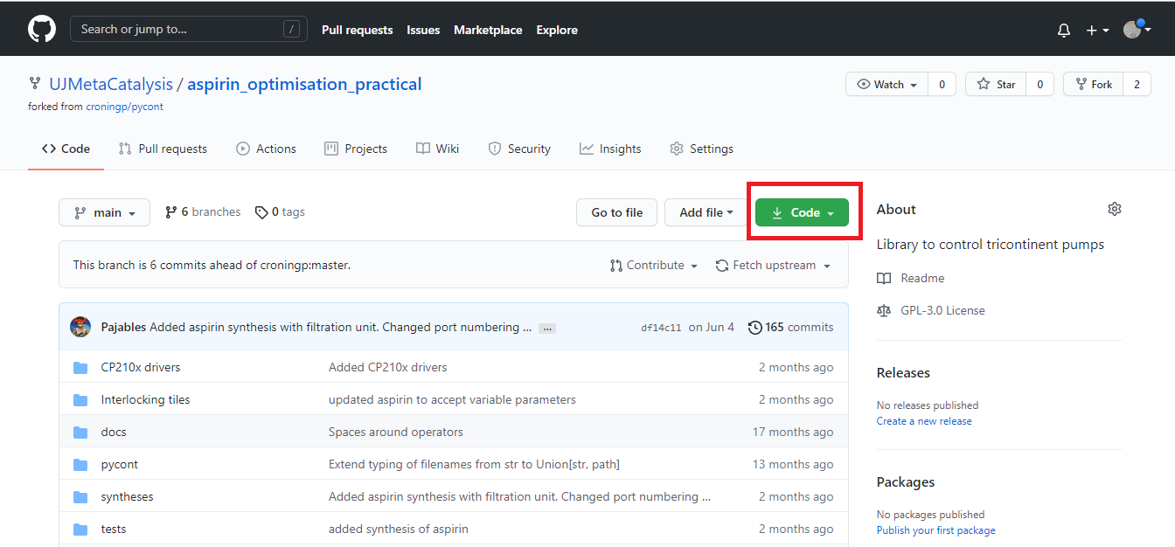

Figure : Downloading the software from Github

Put the files within an easily accessible directory on the computer.

Open a terminal application to do this on Windows search for “Command Prompt”, on Mac OS search for “Terminal” in Launchpad, and on Linux by pressing CTRL + ALT + T (this combination might vary depending on the Linux distribution). If you have installed Anaconda, use the Anaconda terminal instead as the OS terminal will not work. The text to the left of the text cursor indicates the current file directory on your computer that the terminal is operating within. Commands will operate in the context of this directory. You need to navigate to the folder where you unzipped or cloned the repository. To move to the required directory, type “cd” into the terminal followed by the directory name, e.g., “cd FOLDER_NAME” and press enter. Use “cd ..” to move up a directory. You can chain cd commands to get into a folder, e.g: “cd ROOT_FOLDER/SUB_FOLDER1/SUB_FOLDER2”

Once you are within the asprin_optimisation_practical directory, install the Pycont package by entering “python setup.py install” and pressing enter.

Figure 2: Navigating the terminal and installing pycont

To run the asprin synthesis, we also need the “progress” module. Within the terminal, use pip to install the progress package. Pip is a package manager for Python that automatically fetches and installs packages from a cloud repository. To install progress, enter “pip install progress” into the terminal and press enter.

**USB drivers**

Within the folder where you extracted or cloned the aspirin_optimisation_practical repository, locate the folder called CP210x drivers. These drivers enable the PC to communicate with the Tricontinent pump over a USB connection. Install the driver that corresponds to the operating system you are using.

# Performing reactions

**Setting up the apparatus**

1. Prepare excess quantities of water, sulphuric acid and acetic anhydride. Also prepare a chilled water bath for the reactor. Schott bottles with 3 mm holes drilled in their lids were used to hold the fluids. Place 5g of salicylic acid into the round bottom flask using a funnel. Interlocking tiles are included in the repository to hold Schott bottles, a stirrer hotplate, and the Tricontinent syringe pump.
2. Connect the tubing to the pump. The pump uses ¼”-28 fittings for flangeless male nuts. Don’t use excessive force to attach the nuts. The ports should be attached as follows:
   1. Port 1 is attached to the water.
   2. Port 2 is connected to the acetic anhydride.
   3. Port 3 is connected to the conc. sulphuric acid.
   4. Port 4 is connected to the waste bottle.
   5. Port 5 is not used.
   6. Port 6 is connected to the reactor.
3. Connect the condenser to the recirculation chiller and start the chiller.
4. Connect the USB to your computer and make sure the pump is powered, green lights should be visible from the top of the pump.
5. Determine which serial port the pump is connected to:
   1. On Windows: Open the Device Manager, on Windows 10, right click on the start button and select Device Manager, on older versions of Windows navigate to it using Control Panel. Expand the dropdown titled “Ports (COM & LPT)”. Take note of the COM number of the Silicon Labs Serial to UART converter.
   2. On Linux or Mac OS open a terminal window and enter “ls /dev/*usb*”. Copy the output, looking for “serial to UART”.
6. Navigate to the folder where you unzipped or cloned the aspirin_optimisation_practical repository and open the aspirin.json file in the Syntheses folder using a text editor.
7. Find the “port” entry in the file and change the string after the colon to the value for the serial port you found in step 5 (“/dev/xxxx” in Linux or Mac OS, “COMX” in Windows). Save the file and close it.
8. Open a terminal window, navigate to the syntheses folder using cd, and run aspirin.py using “python aspirin.py”.
9. Prime the tubing to remove air. This can be done using option P in the script menu displayed in the console.
10. Prime the port 1 tube by first routing the tube to waste, then using option F in the script menu. Return the port 1 tube to the round bottom flask. This must be done after each reaction to remove water remaining in the tubing.

**Running a reaction**

1. Begin preheating the stirrer hotplate to the temperature required.
2. Place 5g of salicyclic acid into the reactor.
3. Run asprin.py using the terminal. Selected option S and enter the required reaction parameters.
4. Wait until the reaction is complete and remove the products from the round bottom flask.

# Generating reactions with LabMate.ML [OPTIONAL]

**LabMate.ML installation**

LabMate.ML is a Python program that is used to identify optimised reaction conditions using an adaptive random forest heuristics module [2]. LabMate.ML can be found at:

<https://github.com/tcorodrigues/LabMate.ML>

Download the zip file containing the package. It is recommended that the files be saved to an easily accessible location on the PC. The environment can be built from the environment.yml file using conda. The environment collects the required version of Python and required packages for the program. This requires an Anaconda installation.

Figure 3: Creating the environment using conda

Creating the environment will take a few minutes. Once the environment is set up, you can enter it using the command “conda activate LabMate.ML”, see Figure 3. To exit the environment, use the command “conda deactivate”.

Figure 4: Entering the Labmate environment

**Procedure**

The aspirin synthesis and optimization are conducted as follows:

1. Use LabMate.ML initializer to generate ten sample reactions
2. Set up the apparatus and connect the PC to the pump using the USB cable.
3. Perform five of the ten sample reactions and determine the reaction yield, conversion, or another measure of the outcome.
4. Append a tab-separated column to the train_data.txt file with the outcomes of the five selected reactions. Remove the rows for the reactions that were not performed.
5. Use the LabMate.ML optimizer to optimize the reaction conditions based on the performed reactions.

**Generating the sample syntheses**

1. Navigate to the directory where you extracted or cloned LabMate.ML.
2. Open initializer.py using a text editor and edit the reaction parameters, see Figure 4. The numbers in square brackets are the potential values of the parameters. For the aspirin synthesis the volume of acetic anhydride, the volume of water, the temperature of the reaction, and the heating time are parameters that can be optimised.
3. Save and close initializer.py.
4. Using the terminal, activate the LabMate.ML environment (“conda activate LabMate.ML”), and navigate to the folder where you extracted or cloned LabMate.ML using the “cd” command.
5. Enter “python initializer.py” into the terminal and press enter. The script will generate two text files found in the init_files folder. The file all_combos represent the full potential reaction space from the given parameters, and train_data contains a random sample of 10 reactions from the generated combinations.

Figure 5: Setting up reaction parameters

**Running the reactions**

1. Select 5 sample reactions from the train_data.txt file generated by LabMate.ML.
2. Begin preheating the stirrer hotplate to the temperature required.
3. Run asprin.py using the terminal. Selected option S and enter the required reaction parameters.
4. Wait until the reaction is complete and remove the products from the round bottom flask.
5. Replenish the salicylic acid and repeat steps 2-4 using the new reaction conditions until all five reactions have been completed.